Weekly Ringstead Newsletter –15th June 2018
The week ahead…
Monday  18th June | Assembly in Church at 10am – All Welcome  Shine Club 3.20pm – 4.20pm  Tri-Golf Competition – Year 3/4 – 3.30pm – 6.00pm
Tuesday  19th June | 2.45pm – Residential Trip – Parents Meeting  Transition for New Reception 1.30pm – 2.30pm
Wednesday  20th June | History off the Page – Year 3/4
Thursday
21st June
Friday  22nd June | Transition for New Reception 9.00 – 10.00am  Summer Fayre – 3.00pm – 4.30pm



Star of the Week!
The children below were presented with a
Certificate in Achievements Assembly on Friday 15th June 2018
Reception Star of the Week – Henry Scattergood
Year 1 Star of the Week – Maisey Baker
Year 2 Star of the Week – Shania Smith
Year 3 Star of the Week – Kuba Gil-Watson
Year 4 Star of the Week – Sophie Richardson
Year 5 Star of the Week – Gary Siggery
Year 6 Star of the Week – Emily Daly
Head Teacher’s Award – Olive Harrison

Happy Birthday

Kuba, Olly, Izzy,

Have a great day!

.



Head Teacher’s Challenge

Do you know 10 facts about the World Cup?

Well Done to Matila, Kuba and Sophie S who completed last weeks challenge.

Times Tables Rock Stars
Well Done to – Grace,
Izy and Maya you are top
of your class leaderboard and
win 5 house points!
Can you knock them of the
top spot next week?
Handwriting
Heroes
Jenson -
You are this weeks
Handwriting Hero!
Reading Champions
Well Done Lion Class -
58% of you read 5 times this
this week.

Well Done Georgina- winner of last weeks £5 book token.
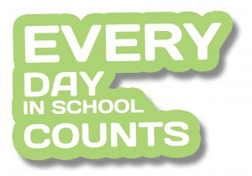
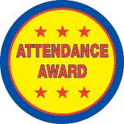



Attendance Winners!
Congratulations to Lion Class who were this
week’s winners with 99.17%.

