Weekly Ringstead Newsletter –8th June 2018
The week ahead…
Monday  11th June | Assembly in Church at 10am – All Welcome  Shine Club 3.20pm – 4.20pm  New Parents Meeting for EYFS – 6.00pm
Tuesday  12th June | Transition for New Reception children 1.30pm – 2.30pm
Wednesday  13th June | RSA – Afterschool –Fathers- Day Gift Wrapping 3.20pm – 4.30pm
Thursday
14th June
Friday  15th June | Transition for New Reception children 9.00am – 10am  Mufti-Day for RSA Summer Fair - £1 donation



Star of the Week!
The children below were presented with a
Certificate in Achievements Assembly on Friday 8th June 2018
Reception Star of the Week – Lily Downs
Year 1 Star of the Week – Leah Gedge
Year 2 Star of the Week – Corey Farr
Year 3 Star of the Week – Jack Eldridge-Bruce
Year 4 Star of the Week – Phillip Smith
Year 5 Star of the Week – Grace Kelly
Year 6 Star of the Week – Beth Shaw
Head Teacher’s Award – Florence Howes

Happy Birthday

Billyjean, Scarlett, Taiton, Owen , Corey, Brooke C,

Have a great day!

.



Head Teacher’s Challenge

It is the 50th Anniversary of Judith Kerr – A Tiger Who Came to Tea. What other books has she written?

Well Done to Kuba and Maya who completed last weeks challenge.

Times Tables Rock Stars
Well Done to – Grace,
Izy and Maya you are top
of your class leaderboard and
win 5 house points!
Can you know them of the
top spot next week?
Handwriting
Heroes
Flori Barnes -
You are this weeks
Handwriting Hero!
Reading Champions
Well Done Lion Class -
58% of you read 5 times this
week.

Well Done Georgina - winner of last weeks £5 book token.
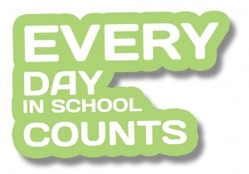
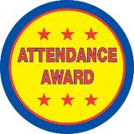


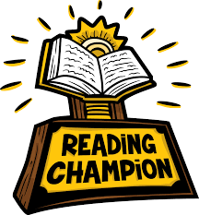
Attendance Winners!
Congratulations to Panda Class who were this
week’s winners with 96.50%.

