Weekly Ringstead Newsletter –13th July 2018
The week ahead…
Monday  16th July | Assembly in Church at 10am – All Welcome  PDET Sports Day  Bikeability - Year 6
Tuesday  17th July | Transition for New Reception 1.30pm – 2.30pm  Bikeability – Year 6  Graduation Evening at 6pm - Year 6
Wednesday  18th July | Sports Day at the Rec - 9.30am
Thursday  19th July | Leavers Service in Church at 2pm
Friday  20th July | SCHOOL CLOSED FOR THE SUMMER



Star of the Week!
The children below were presented with a
Certificate in Achievements Assembly on Friday 16TH July 2018
Reception Star of the Week – Seth Sinfield-Brown
Year 1 Star of the Week – Maisey Baker
Year 2 Star of the Week – William Buckley
Year 3 Star of the Week – Harrison Joyce
Year 4 Star of the Week – Charlie Howes
Year 5 Star of the Week – Chelsea Smith
Year 6 Star of the Week – Tyler Hall
Head Teacher’s Award – Mira Dorascu

Happy Birthday

Amy, Winnie

Have a great day!

.



Head Teacher’s Challenge

Take photo during the Summer Holiday of you reading is obscure places. Send Photos to Mrs Cave at bursar@ringstead.northants-ecl.gov.uk

Well Done to Kuba who completed last weeks challenge.

Times Tables Rock Stars
Well Done to – Grace,
Izy and Maya you are top
of your class leaderboard and
win 5 house points!
Can you knock them of the
top spot next week?
Handwriting
Heroes
Amelia Barnes -
You are this weeks
Handwriting Hero!
Reading Champions
Well Done -
of you read 5 times this
this week.

Well Done - winner of last weeks £5 book token.
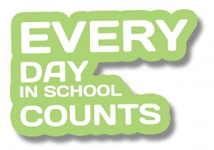
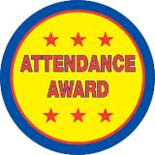



Attendance Winners!
Congratulations to Lion Class who were this
week’s winners with 96.67%.

